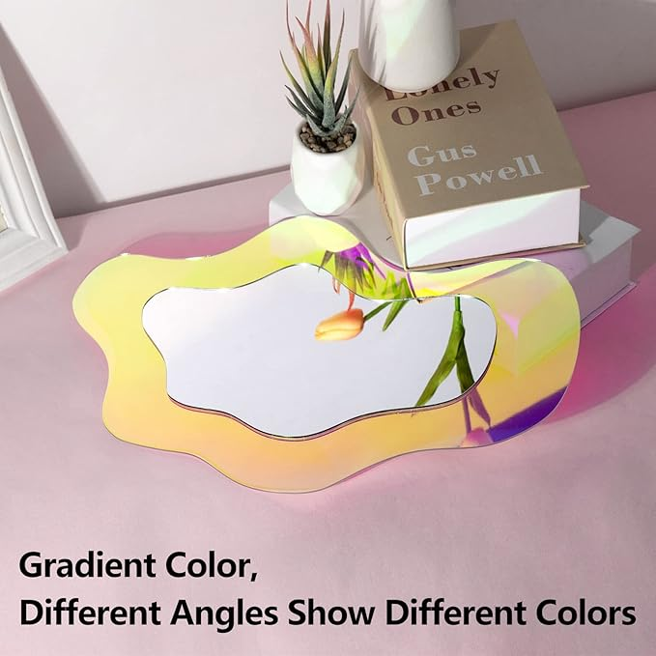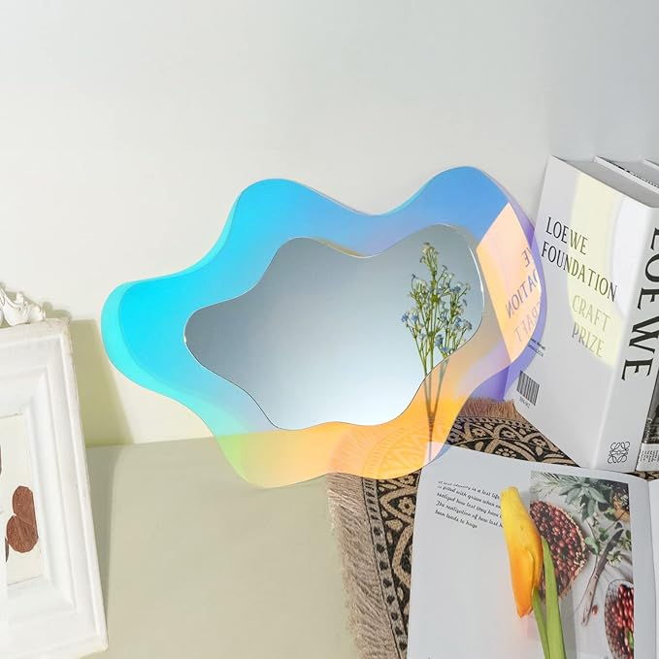

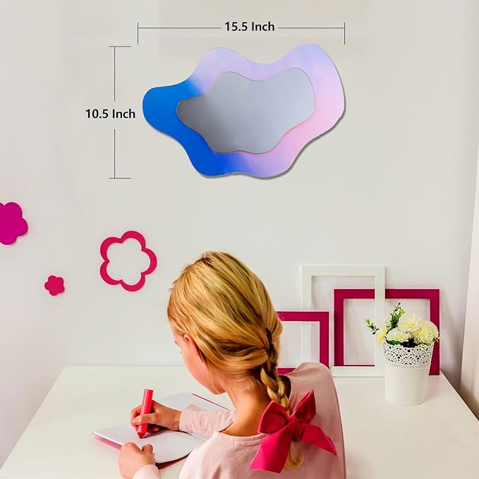

Irregular Wall Mirror Wavy Acrylic Rainbow Mirror Room Decor Aesthetic Mirror Amorphic Vanity Retro Mirror for Bedroom Living Room Bathroom Entryway Wall Decor ( Clouds Style, 15.5 x 10.5 Inch )

**PRODUCT INFORMATION:**

|  |  |
| --- | --- |
| Brand | UNBREAKABL MIRO |
| Room Type | Dressing Room, Bedroom, Living Room, Hallway, Dining Room |
| Shape | Cloud |
| Product Dimensions | 15.5"L x 10.5"W |
| Frame Material | Plexiglass |

**About this item**

* Interesting art design : Irregular wall mirror decoration is composed of transparent wavy rainbow on the outer frame and acrylic mirror in the middle. It is aesthetic wall mirror, can change colors with different light, and display interesting and magnificent charming gradual effect. wavy mirrors can easily attract people's visual focus.
* Secure Rainbow Mirrors : Funky decor composed of shatterproof plexiglass acrylic is not glass, There is no need to worry about accidentally hurting your hand. retro room decor mirrors are very safe for children and pets to have fun.
* Easy to install : Unique home decor, In order to better present the colorful light art, you need to choose the ideal position for the rainbow wall mirror, do some comparative experiments with different beams in different places, and then decide to stick it on the smooth wall with double-sided tape.
* Appropriate size : The aesthetic mirror size is about 15.5 x 10.5 Inch, which adds elegance and atmosphere to your interior decoration without taking up too much space. Please remember to peel off the protective film on the base and mirror before use, so that the effect is clearer.
* Extensive application : Cute retro decor asymmetrical mirror is suitable for decoration on any wall you need in your bedroom, wardrobe, hallway, living room, bathroom and dressing table, and can also be placed on your desk, which is more suitable for any activity and holiday celebration. Therefore, it will be a very good choice to give a cosmetic mirror as a gift to your family or friends.